1. Using a HTML editor, create the below layout with borders

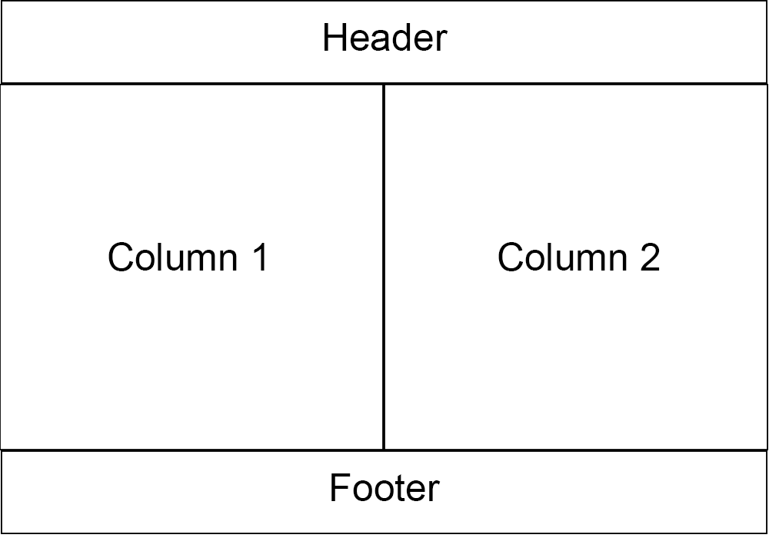

- In the header add a centered image using the following url: https://skin.thebathroomboutique.co.uk/skin/frontend/default/bathroom/images/TBB-logo.png
- In column 1, add a bullet point list of your 5 favourite TV shows.
- Add a link to the following site https://www.theheatingboutique.co.uk/
- In column 2, add a form. The form should contain the following
  - A dropdown with the options - “England, Germany, Italy, France, Spain”
  - Two radio buttons with the labels “win” and “lose”
  - Add a button to the form
  - Use Javascript/JQuery to display the selections in an alert box when the button is clicked - e.g “England Win”

2. Using PHP or Javascript/JQuery write a script that does the following

- Counts from 1 to 100 and prints each number on a new line.
- If the number is divisible by 3 print “foo” instead of the number
- If the number is divisible by 5 print “bar” instead of the number
- If the number is divisible by 3 and 5 print “foobar” instead of the number

